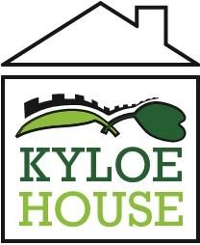

Additional information for teaching candidates.

Kyloe House is a secure children’s home that offers education for up to 14 young people aged 10 - 17. We are seeking to further develop and strengthen our education team at Kyloe House.

We are looking for an individual who can form effective and engaging relationships for learning with all colleagues and young people. We wish to appoint an effective teacher who will continue the development of our current high quality care and learning provision. The individual should bring creativity and innovation to developing a curriculum that meets individual needs, and be able to oversee the development of the provision that gives flexibility across key stages and subjects. A new member of the education team will need an engaging personality and a commitment to young people’s learning

We require the successful candidate to be:

- A highly motivated and inspirational teacher with a successful track record in working with children with a wide range of educational needs
- Able to understand data and its use for assessment to drive the school forwards
- A teacher with either QTS or QTLS with a minimum of 3 years post qualifying experience
- A team player who is able to respect others, motivate, lead, support and challenge
- A strategic thinker who is able to motivate and inspire disaffected young people.
- Able to teach a curriculum subject.
- An understanding of the Special Educational Needs of young people.

If you require further information, please contact Cathryn Hill – Head of Education on 01670 785900 or at cathryn.hill@Northumberland.gov.uk

