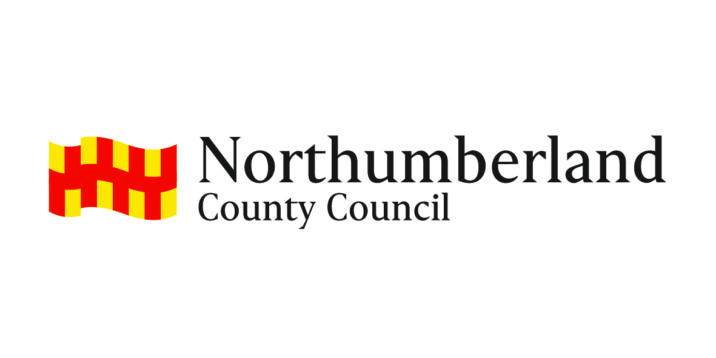
JOB DESCRIPTION

Post Title: Family Hub Practitioner |  | Director/Service/Sector: Children, Young People & Education/ Children's Social Care, Young People and Families |  | Office Use
Grade: Band 4 |  | Workplace: Family Hub Locality Base |  | JE ref: 4277  HRMS ref:
Responsible to: Family Hub Manager |  | Date: June 2023 | Manager Level: N/A
Job Purpose:

- To provide a Children & Young People (C&YP) service, working directly with C&YP and their families to offer high quality play experiences in the Family Hub and on an outreach basis.
- To provide direct work with C&YP and/or their parents/carers on an individual and/or group basis which holistically supports the C&YP’s needs and gives them the best start in life.
- To work in partnership with Family Help Teams and other colleagues, statutory and voluntary to support families to achieve the best outcomes possible.
Resources | Staff | N/A
Finance |  | N/A
Physical |  | Play vans
Clients |  | Families, Partners, stakeholders and volunteers.
Duties and key result areas:

Responsibilities:

- To provide a high-quality play and learning service on an individual and group basis, for example, Learning Together Through Play (LTTP) sessions, outreach services and/or evidence-based interventions in accordance with agreed Pathways.
- To provide a play and learning service for isolated rural communities working on the principle of taking services to families as needed.
- To provide individual and group work programmes for parents based on supporting the holistic needs of C&YP (0-25 SEND). .
- To provide low level assistance to Family Help teams and other colleagues which supports families to achieve positive outcomes.

Specific Duties:

- To undertake one to one home visits to families, as required, on a referral basis to support their development, for example support to the Speech and Language Therapists or the Family Help Workers.
- To provide objective and accurate feedback and reports for families and other professionals on C&YP’s achievements, progress and related matters.
- To plan and prepare play and learning opportunities that reflects the EYFS framework and Best Start for Life where appropriate.
- The ability to design and implement a creative and innovative play and learning environment through the use of a range of resources, both indoors and outdoors, to meet the needs of families.
- Preparing and creating wall displays of C&YP’s work to celebrate their achievements and learning.
- To work collaboratively with local families to develop understanding about how children play and learn.
- To plan and deliver a programme of play and learning activities based on agreed pathways.
- To deliver individual and group-based programmes for families to support the needs of C&YP and enable them to have the best start in life.
- To clean and maintain equipment and resources.
- To work closely with local families and Family Hub staff to ensure services meet the needs of families.
- To drive and operate an appropriate vehicle Such as a Van or People Carrier, and to carry out routine checks before and after use on the vehicle.
- To work in partnership with other members of the Family Hub and other agencies in order to build and develop the service.
- To monitor and evaluate the impact of the service on families using a range of participative techniques.
- To maintain health and safety standards in line with good practice and Northumberland County Council’s own in-house policies including carrying out daily risk assessments.
- Participate in the identification of personal training and development needs and to make full use of training and development opportunities.
- Responsibility for helping to keep C&YP safe by providing a safe environment for C&YP to learn in.
- Identifying children and young people who are suffering or likely to suffer significant harm and take appropriate action with the aim of making sure they are kept safe.

Other:

- At all times to carry out duties in accordance with Northumberland County Council’s Equal Opportunities Policy and within the spirit of Anti-Discriminatory practices.

The duties and responsibilities highlighted in this Job Description are indicative and may vary over time. Post holders are expected to undertake other duties and responsibilities relevant to the nature, level and extent of the post and the grade has been established on this basis.
Work Arrangements
Transport requirements:  Working patterns:  Working conditions: |  | Able to meet the transport requirements of the post. The work involves the need to visit outreach bases and Hubs across a locality area and a play van/people carrier will normally be provided for this where possible. Therefore, a driving licence is required  Able to work flexible hours as necessary, this may include evenings and weekends.  Lone working involved

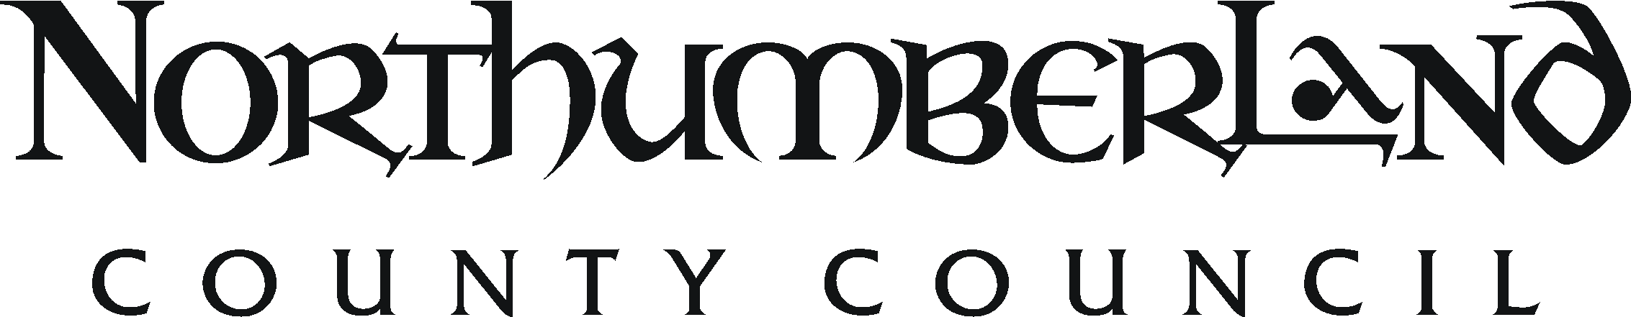 PERSON SPECIFICATION

Post Title: Family Hub Practitioner | Director/Service/Sector: Children, Young People & Education/ Children's Social Care, Young People and Families | Ref:
Essential | Desirable |  | Assess  by
Knowledge and Qualifications
- Level 3 qualification in Early Years or Youth Work, eg NNEB, BTech, NVQ Level 3 or similar  - Knowledge and understanding of current family practice and/or child development  - Knowledge and understanding of how C &YP play and learn  - Knowledge and understanding of Safeguarding issues  - Trained to deliver relevant group work programmes, such as HENRY  - Knowledge of Early Intervention and Prevention, and an understanding of the importance of supporting families to achieve good outcomes.  - Knowledge and understanding of the use of outcomes tools to track C&YP’s progress. | - Relevant play or youth work qualification  - First Aid  - Safeguarding children  - Relevant speech and language qualification
Experience
- Experience of working with C&YP in a group setting  - Experience of providing play and learning opportunities for C&YP linked to their developmental stage  - Experience of working in partnership with parents, carers and C & YP , and other agencies  - Experience of direct work with parents for the benefit of C & YP | - Experience of a variety of family work  - Experience of undertaking developmental work
Skills and competencies
- A creative and innovative approach to play and learning
- Excellent interpersonal and communication skills (verbal and written)
- Ability to plan and evaluate activities
- Ability to manage own workload and work under own initiative
- Ability to keep records
- Ability to work alone and as part of a team

Physical, mental and emotional demands
- Commitment to and ability to work in partnership with families, carers and C&YP
- Have a flexible approach to work
- A commitment to undertake further training
- Commitment to all aspects of equal opportunities including commitment to anti-discriminatory practice
- Commitment to keep C&YP safe by providing a safe environment for children and young people to learn in
- Commitment to identify children and young people who are suffering or likely to suffer significant harm and take appropriate action with the aim of making sure they are kept safe
- Commitment to the vision and principles of Family Hubs
- Physically capable of discharging the full duties of the post

Other
Key to assessment methods; (a) application form, (i) interview, (r) references, (t) ability tests (q) personality questionnaire (g) assessed group work, (p) presentation, (o) others e.g. case studies/visits

