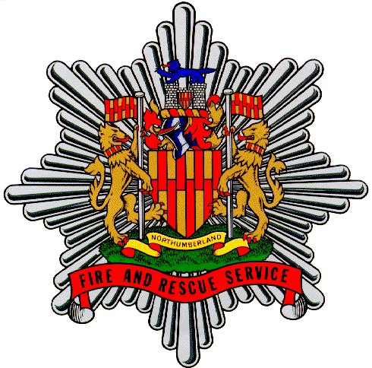
NORTHUMBERLAND FIRE &

RESCUE SERVICE

Some facts about Fire Control……..

Please take time to consider if the working environment in Fire Control will suit you:

You will wear a uniform and you will work in a disciplined environment

You will need to invest your own time, outside of work to successfully complete the initial Firefighter (Control) Training Course

After training, you will work 2 day shifts (0900 to 1800 hours) and two night shifts (1800 to 0900 hours), then have four days off

This means you will work two successive 15 hour nightshifts

- Your Annual Leave is scheduled for you throughout the year, you will be expected to work Bank Holidays, including Christmas and New Year

You will spend most of your shift sitting at a desk in front of computer screens

You will not be allowed to leave the site during your shift and you may be called back to your desk during meal breaks

The shift system may interfere with your social life

You will spend your working time in one Control Room

- You will work with the same three or four people every day and you will not see many other people

- Most of your contact with colleagues outside of Fire Control will be by telephone only

- Sometimes you will be extremely busy, but some shifts may be fairly quiet

- Some of your callers may be difficult to deal with

